Timetable for Week 7

Monday | Tuesday | Wednesday | Thursday | Friday
Morning | Morning | Morning | Morning | Morning
Reading: 15 minutes of own text (all pupils have taken home five books of different genres).  English: Begin planning out persuasive writing (stay at poshest hotel). See page 2.  Maths: Ruler Reaction investigation- see attachment. Please read through with your child so they understand. Select a few predictions from list to initially test and record results. | English: Begin writing based on plans from yesterday.  Maths: Continue Ruler Investigation from yesterday. Test out more predictions ensuring a ‘Fair Test’. Record results. Test more people where possible.  English: Complete first version of persuasive writing from yesterday. | Reading: 15 minutes of own text.  English: ‘Edit and Improve’ hotel work. Check punctuation, spelling, grammar and sense. Add a picture. Please e-mail!  Maths: Begin completing some of the suggested activities at the bottom in dark red of the attachment. Complete this tomorrow. | Reading: 15 minutes of own text.  English: 20 minutes of SPaG revision (using book supplied).  Maths: Complete Maths investigation. Finish activities at bottom of the attachment in dark red, and write up findings. Please e-mail me finished work (I want to pass some Maths work on to Dowdales). | Reading: Free-choice reading. Magazine, newspaper, etc.  English: Complete a reading journal activity.  Maths: Times-table Rockstars (20 minutes).  Maths: Revision- It’s important to keep this up, so thirty minutes revising (revision book). Focus on glossary pages.
Afternoon | Afternoon | Afternoon | Afternoon | Afternoon
Art: Whole-school activity. See separate e-mail sent today. Making a ‘thank you’ greeting for someone who does one of the jobs outlined in the attachment (or another job that would be classed as employing ‘key workers’). Details are in the attachment. Please ask your child to do this activity so that Year 6 are well represented when published. | Art: Self-portrait. Continued tomorrow. Perhaps take a picture so they can work from that. Link provided on page 2 for hints on how to do self-portraits (step-by-step)  PE: A brisk walk, jog or cycle-ride with parents as part of the ‘outdoor exercise’ guidance (*unless this suddenly changes). | Art: Complete yesterday’s activity, take a photo and send to me if at all possible. Will I be able to tell who it is?  Science: Natterjack toads. Research these (rare, and found in Askam), sketch, label, etc. Think about colour, size, diet, life-span, habitat, numbers, special facts about them, etc. Complete tomorrow. | Science: Complete yesterday’s activity. Please ensure your child is doing this using their own words and not simply copying from the internet.  Finishing Off: Complete any work that remains unfinished. | Free Choice- anything that does not involve i-pads, computers, etc. Ideas: Baking, singing, dancing, sewing, knitting, gardening, helping with jobs, jet-skiing…  If possible, take a picture and send.  Please send through any work and pictures.
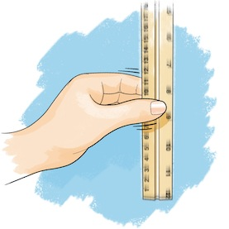
Maths: Please ask mums or dads to print out the attachment for this activity. It’s all about investigating statements relating to how quickly you can ‘catch’ a ruler between certain fingers or thumb when dropped by someone else. It is five years since I last did this investigation with a class. They enjoyed it, and I hope you will too. Please try to present your work neatly. As I said last week, I am going to send some of the work you have done in these investigations to the maths department at Dowdales. Make sure you keep your yellow books. Please ask parents to photograph and send me your work. You all took home a school ruler with your name on it, so hopefully you will all still have these. Please ask if you don’t fully understand the instructions. Hopefully, you’ll enjoy doing this.

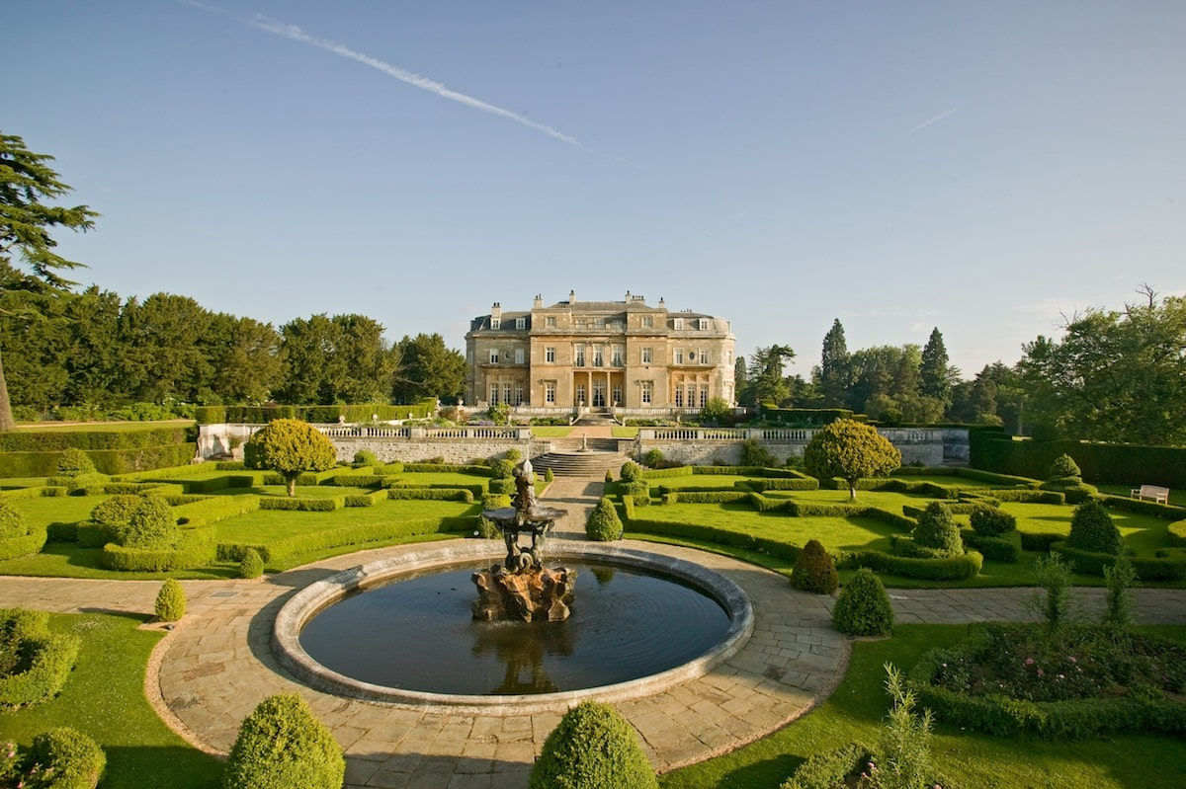
English: This is a persuasive piece of writing. Your mission is to try and persuade someone to visit and stay at England’s poshest hotel through writing a description that makes it sound very appealing. You’ll need to use lots of hyperbolic adjectives (‘stunning’, ‘magnificent’. ‘world-class’, etc.) to persuade people that it is worth visiting. Sometimes write in the ‘second person’ (You will feel utterly relaxed from the moment you drive through our gates). Think of a grand-sounding name for it. Think about the hotel’s grounds. What does the exterior of the hotel look like? What is the reception area like? Think about porters, etc. Describe the rooms. What about the food and drinks? What facilities does the hotel offer? You need to use quite formal language with this activity. Include some pictures! Get ideas from the internet- research posh hotels. Remember, you are trying to persuade someone to visit through your vivid description. This is a written advertisement for an extremely posh hotel. I have given you a few pointers in the attachment- please ask parents to show you.
Art: I would also really like you to complete the whole-school activity. I am not going to repeat it here, but it is all set out in the separate e-mail I sent mums and dads earlier today. Please do your best with this activity, and I look forward to seeing your finished creations!
More Art! I am going to ask you to have a go at doing a self-portrait or a portrait of a willing brother or sister. I would concentrate on the face and maybe shoulders down to about chest-height. You’ll need some plain paper and a pencil (I gave you both to take home). If we were in school, we’d watch some tutorials about how to do this effectively. There are some links below. These should really help you be more successful with this activity. I look forward to seeing your pictures!
https://www.youtube.com/watch?time_continue=35&v=wfosxuah1uk&feature=emb_logo (There’s no sound, but it is quite good- make sure you see Powerpoint below).
http://resources.hwb.wales.gov.uk/VTC/ngfl/art/122/drawing_portraits/howtodrawaportait.ppt (This is a really good Powerpoint to watch which does it step-by-step).
Other Activities: These are all explained in the information for parents on page 1, and should be fairly obvious. Hope my photographers take some more pictures too

