ENGLISH ACTIVITY 1
I thought that it would be lovely if everybody in Year 2 could write a letter and then I will send them to everyone in Year 2. You will be able to read about what all your class mates are doing. To help you write your letter, I would like you to fill in this grid which you will use tomorrow. When you fill in the grid you don’t need to write in sentences – just use key words to help you when you write your letter tomorrow. We often do this sort of thing in class, so you will know what to do. If you want to draw a few pictures as well that is fine. I have done a plan as well, which I have used when I was writing my letter.
People and pets in my house | Things I have been doing
Things I am missing | Activities I am enjoying doing
Things I am grateful for | Things I am looking forward to doing when we get back to school

People and pets in my house  Mr Roberts Fred Tootsie | Things I have been doing  In school Gardening Reading Writing
Things I am missing  Being a Year 2 teacher Seeing Felicity and Arthur  Seeing my friends Playing badminton | Things that make me happy  Seeing lots of Year 2 pictures Having a neat garden  Seeing videos of Felicity and Arthur and chatting to them on the phone
Things I am grateful for  Being fit and healthy Going for walks every day  Living in a lovely part of the world | Things I am looking forward to doing when we get back to school  Seeing you all again and having lots of great activities to do  Having lots of laughs

ENGLISH ACTIVITY 2
Today, I would like you to use your plan from yesterday to write your letter to Year 2. Remember to use capital letters, neat handwriting, conjunctions to link simple sentences and lots of descriptive phrases. If you want to include some pictures or drawings as well, that would be great.
I hope that you enjoy reading my letter to you.
30th April 2020

Dear Year 2,

Hello, I hope that you are all well and enjoying spending this special time with your family at home.
Mr Roberts is being very helpful to me as he understands that I am having a different time right now. He is very good at getting me cups of tea when he realises that I need one! Fred and Tootsie don’t understand about Covid 19 and they continue with their usual routine of sleeping most of the time during the day and bringing in mice to show me! Sometimes the mice are still alive.

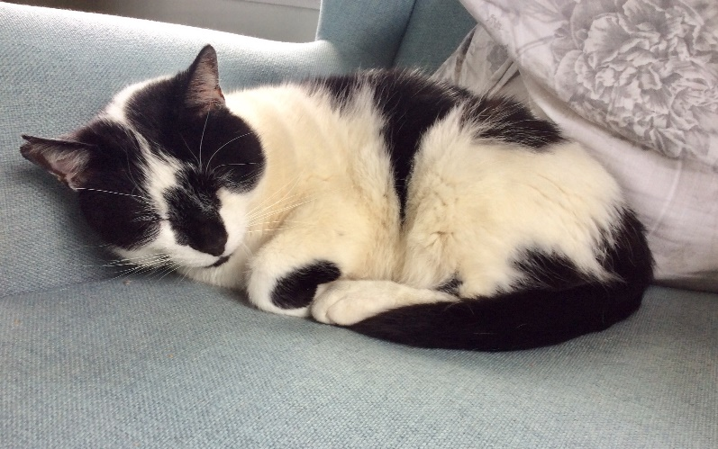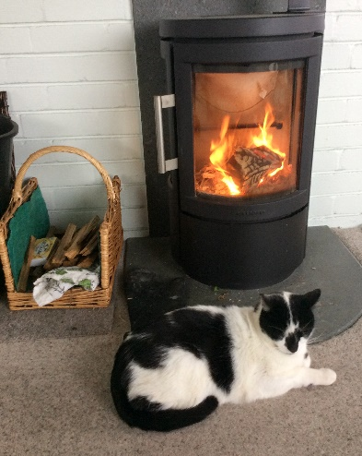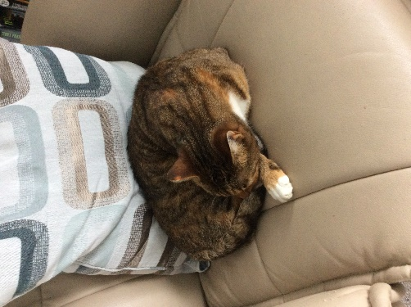

When this happens I have to get Mr Roberts to rescue them and take them back outside. Not a job for Mrs Roberts for sure!

I do still go into school as it is open for children of key workers. It is very different from being a Year 2 teacher, but it is lovely to see some familiar faces and hear what they have been doing.
When I am not in school I like to spend time in my garden. The weather has been wonderful and sunny. This has meant that I can spend time swinging on my garden seat and enjoying looking at my garden.

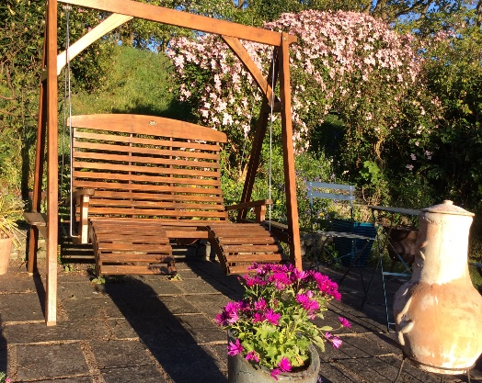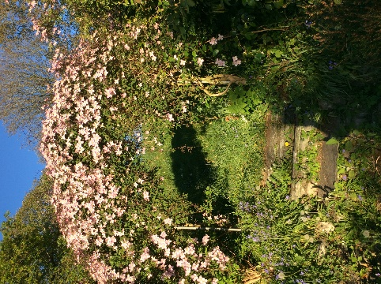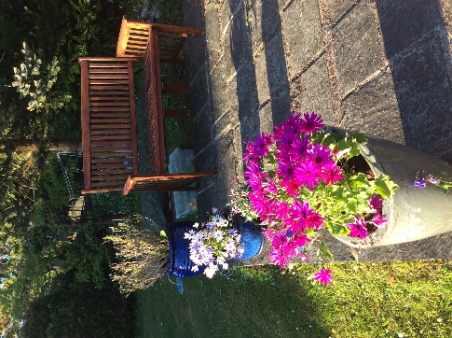

This is the time of year when lots of flowers and shrubs burst into life. My garden is very colourful at the moment. It has never looked so neat before! I am also busy planting lots of new plants which I am hoping will grow well during the summer months. The swings are ready and waiting for Felicity and Arthur!
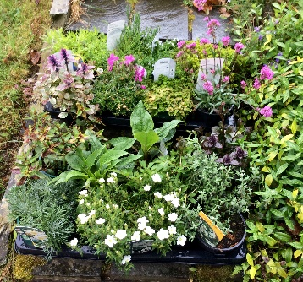
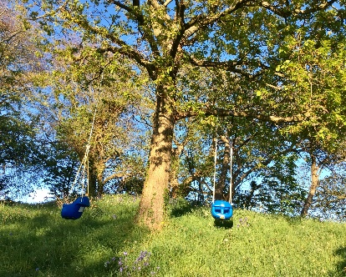

Although I can’t see my girls or Felicity and Arthur, I do send them cards and small parcels every week. I know that they look forward to reading their letters and looking at the pictures I send them.
I have also made some signs which I have stuck on my wall for people to see as they walk past.

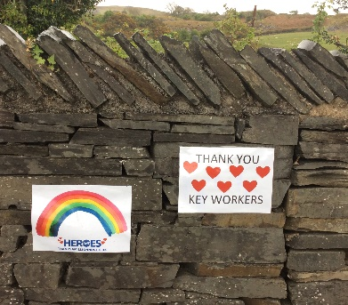

It is a different time for everyone right now, it is strange not teaching a class or seeing my friends, or playing badminton. But there are things which help to keep me happy; like seeing pictures of you doing all sorts of things like planting, being in your allotment, making bird boxes, writing, maths, baking, helping and doing PE with Joe Wickes. I also enjoy having video calls with Felicity and Arthur. Felicity has not learnt to hold the phone properly yet, and I often see very close up images of her eye or looking up her nostrils! Are you able to make phone calls to or see pictures of your friends and family?

Anyway, I am grateful that we are all fit and healthy and that we live in such a wonderful part of the world. We have lots of space and can go for walks on the beach and around the village.

I am looking forward to when we can go back to school and enjoy our time in class again. I have lots of exciting activities planned for us to do. Keep safe and be kind to everyone.

Lots of love,
Mrs Roberts

ENGLISH ACTIVITY 4
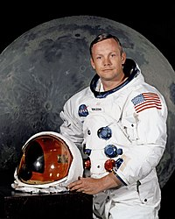

Neil Armstrong was a famous American astronaut. He was the first man to walk on the moon.

He was born in 1930 in the United States of America. Neil Armstrong was only 15 years old when he first got his pilot’s license. After he went to university, he became a test pilot and flew over 200 different aircraft.

In September 1962, Neil Armstrong joined NASA’s astronaut corps, which meant that one day he might go into space!

In 1969, he flew to the moon in a spacecraft called Apollo 11, along with Buzz Aldrin and Michael Collins. On 21st July 1969 when he stepped off his spacecraft he said “One small step for man, one giant leap for mankind.”

They arrived home to Earth on 24th July 1969.

- Why is Neil Armstrong famous?
- When was he born?
- How long was Neil Armstrong when he got his pilot’s license?
- What did he do when he finished university?
- How old was Neil Armstrong when he joined the astronaut corps?
- What was the name of the spacecraft that Neil Armstrong and Buzz Aldrin flew to the moon in?
- When did Neil Armstrong make the first step on the moon?
- What famous statement did he make?
- How many days did it take them to arrive back on Earth?

