Thank you, as ever, for all your wonderful ideas which showcased what a wonderful place Askam is to live and visit. Your photos will be appearing on Facebook class-by-class this weekend. Please find below details about our next whole-school challenge.
National Empathy Day – 9th June, 2020
Many educationalists believe that the most important subject for children to learn about and experience at the moment is not Maths or English- it is actually PSHE. You might know this as ‘Guidance’ / ‘Citizenship’ or by some other name. PSHE stands for Personal, Social and Health Education.
Tuesday 9th June is ‘National Empathy Day’. The purpose of this day is to promote the importance of expressing our feelings, understanding one another’s point of view and taking the time to listen and value the thoughts, ideas and opinions of other people. It is designed to help with mental well-being, and to encourage young people to ‘open up’ and share their worries rather than bottling it all up and feeling they have no-one to turn to when times are tough.
If this is something that interests you, there is a free family pack which can be downloaded. I’ve had a look, and there are some very worthwhile and interesting activities designed to promote an empathetic understanding of one another. As an example, have a look at the activity on Page 14 which is typical of the ideas in the document:
https://irp-cdn.multiscreensite.com/b2f3fbc2/files/uploaded/Family%20Activity%20Pack_Countdown%20to%20Empathy%20Day_June%202020.pdf
This week’s whole-school task is to do something as a family that promotes empathy and mental well-being. Here are some simple ideas from which you might choose one or more:
- Read or listen to a story which stimulates discussion as a whole-family. Listen to one-another. Talk about the text together. Discuss the characters and their actions, along with their feelings at different points of the story. There are many free examples of stories which promote empathy in the link lower down this page.
- Make a worry jar and talk through the concerns that your child has.
- Go for a gentle family walk. Look at the nature all around you. Find out about the birds, insects, flowers, trees or butterflies that you see. What can you hear, smell, touch, taste and see on your walk?
- Listen to some relaxing music- you might even try some yoga or similar as a family.
- Draw a poster promoting empathy or something associated with mental well-being (such as talking to your family and friends about concerns, or (for older children) promoting The Samaritans for example).
- Complete one or more of the activities in the downloadable booklets attached at the bottom of this page.

There are some well-known authors who read their own picture books / poems to the children at the link below. All the texts are designed to promote empathy with one-another. Different texts are for different age-groups. I enjoyed ‘The Truth About Old People’, and I think many of the children in school would too. ‘Elmer’s Birthday’ is another one I would recommend, and there are follow-up activities relating to this text at the link at the bottom of the page.
https://www.empathylab.uk/empathy-read-aloud

As a school, we feel that developing empathy with one another and promoting mental well-being are both incredibly important. Given the situation at the moment, it could be argued that this is more important now than ever before.

Whichever activity or activities you decide to do, it would be lovely if you could take a photograph or two and send them in the normal way. Once again, this is a very open-ended activity. Please could you send any pictures to s.cairns@askam.cumbria.sch.uk from Monday onwards, and please, no names on any work that is produced.
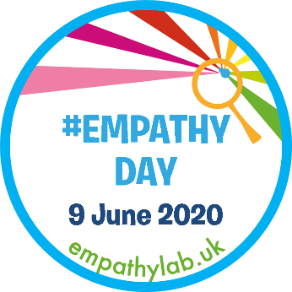
More information and both packs, including some useful resources can be found here:
https://www.empathylab.uk/school-2020-empathy-day-resources plus there is a good
YouTube video which explains what empathy is for younger children here:
https://www.youtube.com/watch?v=9_1Rt1R4xbM&feature=youtu.be

This is my final whole-school challenge. From next week, Mrs. Biggins is kindly going to be setting the challenges. Thank you for your wonderful contributions. I feel like I have got to know many of you over the past few months! Have a happy and safe weekend everyone. Best Wishes, Mr. C.

