Timetable for Week 8

Monday | Tuesday | Wednesday | Thursday | Friday
Morning | Morning | Morning | Morning | Morning
Reading: 15 minutes of own text  English: Begin planning out descriptive writing (visit to dilapidated hotel). See page 2.  Maths: Border pattern investigation- see attachment. Please read through with your child so they understand. Begin investigating problem, gathering results and presenting evidence. | Reading: 15 minutes of either SPaG or Maths revision.  Maths: Complete ‘Border Pattern’ problem from yesterday. Look for patterns. Try to express pattern using an equation (y and x), or in words if that is too tricky  English: Start writing description of the dilapidated hotel (see page 2). | Reading: 15 minutes of own text.  English: Complete description of dilapidated hotel. ‘Edit and Improve’ (ideally with you). Please then e-mail.  Maths: ‘Caterpillar’ investigation. Another short investigation over two lessons (today and tomorrow). See attachment. | Reading: 15 minutes of own text.  English: 20 minutes of SPaG revision (using book supplied).  Maths: Complete ‘Caterpillar’ Maths investigation. Send to me if possible. Am going to be sending some of the work from each pupil to the Maths department at Dowdales, but please keep original work too. | Reading: Free-choice reading. Magazine, newspaper, etc.  English: Complete a reading journal activity.  English: spag.com There should be a new game to play.  Maths: Revision- It’s important to keep this up, so thirty minutes revising (revision book). Focus on glossary pages.
Afternoon | Afternoon | Afternoon | Afternoon | Afternoon
Art: Not necessarily art, but I had to choose a subject title! Why Askam is such a great place to live / visit. Please see separate e-mail sent today. I’ve timetabled this for all afternoon today and part of tomorrow. Please encourage your child to take part in this activity so that Year 6 are well represented on Facebook when the work is published. | Art: Complete yesterday’s whole-school challenge and send through to me if possible via e-mail. Two pictures if possible, including one of your child. Thank you!  PE: A brisk walk, jog or cycle-ride with parents as part of the ‘outdoor exercise’ guidance (*unless this suddenly changes). | Art: Observational drawing of any object within the grounds of your home. Think about light/shadow, shading, etc.  Science: Back to butterflies again, because the butterflies out and about now are different from the ones last time. Children select a type (see attached poster) research it and sketch it- continue tomorrow. Can they see one? | Science: Complete yesterday’s activity. Please ensure your child is doing this using their own words and not simply copying from the internet.  Art: Complete yesterday’s art activity. Add little details as it is these that can ‘make’ a piece of artwork. Photograph and e-mail to me if at all possible. | Free Choice- anything that does not involve i-pads, computers, etc. Ideas: Baking, singing, dancing, sewing, knitting, gardening, helping with jobs, moon landing…  If possible, take a picture and send.  Please send through any work and pictures.
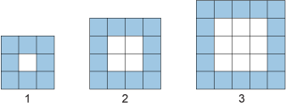
Maths: Two short Maths investigations to complete this week. The first is called ‘Border Patterns’ and is explained in more detail in an attachment I have sent mums and dads. Please ask them to read through the instructions with you, and then you should be fine. Remember, e-mail if you’re unsure. I am always here to help! The second short investigation is called ‘Caterpillars’. Again, more details about this are in the same attachment (just one side of A4), so please ask parents to either print it out for you or ask them to show you it. I think it is quite an interesting investigation. Remember to ask if you’re at all unsure. It’s always a good idea to check you’re doing it right, so you don’t spend a lot of time doing something only to find out you’ve been doing it incorrectly!

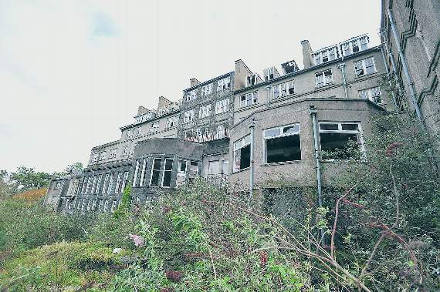
English: If I said to you that the weather last Friday contrasted with this Friday, it would mean the weather was very different on the two days. I am going to ask you to do a piece of descriptive writing which contrasts with the ‘poshest hotel’ persuasive writing you did last time. Imagine a once-grand hotel that has been closed for a number of years. It has just been abandoned and, over a period of time, has become dilapidated. Your task is to describe the different aspects of this hotel in its sorry state. You might think about its grounds, the exterior of the hotel, its reception area, the hallways, the rooms, etc. with various clues that suggest this was once THE place to stay. Hint at its past and its former glory. Take the reader on a journey around this hotel. Include lots of adjectives (‘abandoned’, ‘forlorn’, etc.). This isn’t a persuasive piece of writing, but it is a first-hand detailed imaginary description of what is now a run-down and empty former hotel. I’ve included a picture to get you started, but you might find more photographs to give you some ideas online. Please organise your writing into paragraphs. Be consistent with tenses. Check your work carefully for sense, spelling and punctuation. Try to impress me with the range of vocabulary that you use. Aim for at least a side of A4. The title of your work is up to you. Good luck!
Art: I would also really like you to complete the whole-school activity. I am not going to repeat it here, but it is all set out in the separate e-mail I sent mums and dads earlier today. Please do your best with this activity, and I look forward to seeing your finished work which hopefully they’ll send to me so I can publish them on Facebook.
Science: I’m not cracking up. I know we did butterflies about seven weeks’ ago, but the butterflies you see in April can be very different to the ones you might find in June. I’d like you to try and do some butterfly-spotting on your walks with your parents or in the garden. Can you identify one you see? Can you sketch it and research it? I have attached a poster which illustrates some of the butterflies to look out for in June. I wonder how many different types you can spot, and where do you see them? Some butterflies like to lie on paths, others on nettles, some in meadows and some on top of trees! They’re all different, and that is what makes them so special.
Other Activities: These are all explained in the information for parents on page 1, and should be fairly obvious. Hope my photographers take some more pictures too

