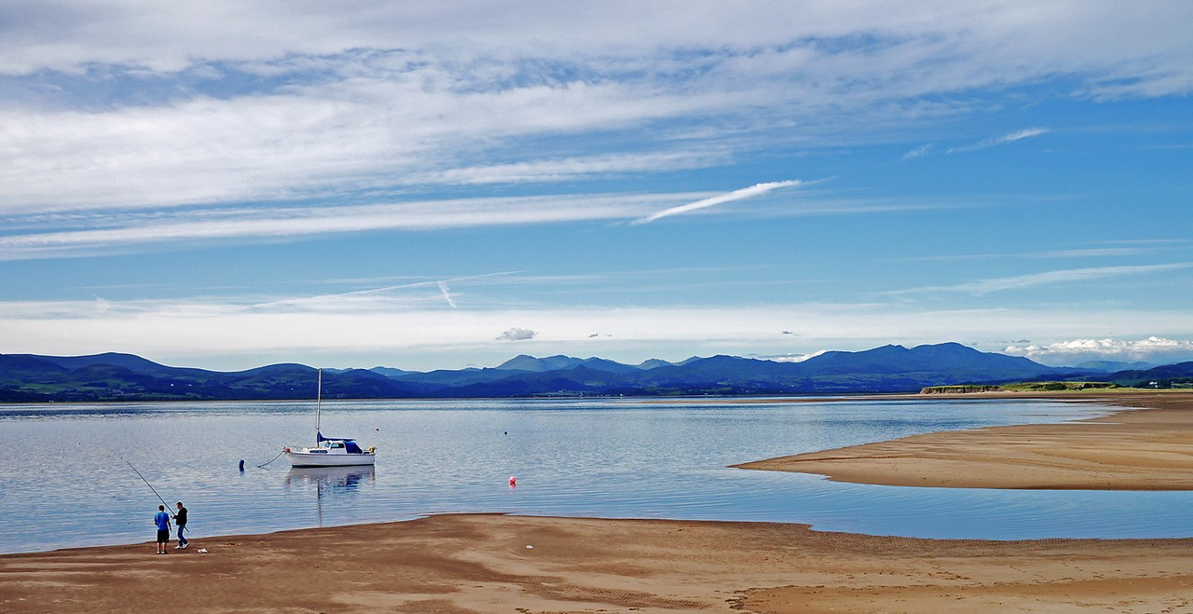
Dear Parents,
I hope this finds you all safe and well.
Thank you for all the lovely entries to our previous whole-school challenge. I am sure anyone involved with any of the jobs featured will be very pleased that people have taken the time to say that they are appreciated.
Our next whole-school task is outlined below:
What makes Askam and Ireleth special to your family? Why is it a good place to live / visit? The children are asked to capture in some way what is great about their village. They might choose to focus on one or more of the following:
Its impressive views Its rich wildlife Its strong community spirit Its important history
It might also focus on something completely different as that is what makes the village special to your family.
The work the children produce, as usual, can take any form as long as it can be photographed and published on Facebook. They might take a photograph to showcase the views, paint a picture, design a poster to attract visitors, research part of the village’s history, find and take pictures of some examples of local wildlife, write a poem, or something else that fits in with the task.
If you don’t live in either Askam or Ireleth, your child could either produce something about the place you live (e.g. Kirkby), or if you prefer, you could still do Askam because that is where they attend school.
The photographs you submit will all be published class-by-class next weekend, so please can they be sent to me by Friday to the following e-mail address: s.cairns@askam.cumbria.sch.uk . Please send from Monday onwards.
Please don’t put your child’s name on any work that is produced. If you send two images (one of any work produced and one with your child holding that work) then people should be able to identify individuals in each class. If your child is submitting a photograph, you could also include a picture of them holding the camera (and I’ll publish the photos alongside one another), or print out the photograph and take a picture of them holding it.
Again, you can help me by adding your child’s name and year-group in the subject bar.
Wishing you all a happy and safe weekend.
Best Wishes,
Mr. C.
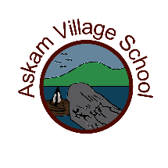
Thank you to Askam and Ireleth Parish Council for letting me use the photograph at the top of the page.

